1. 
2. 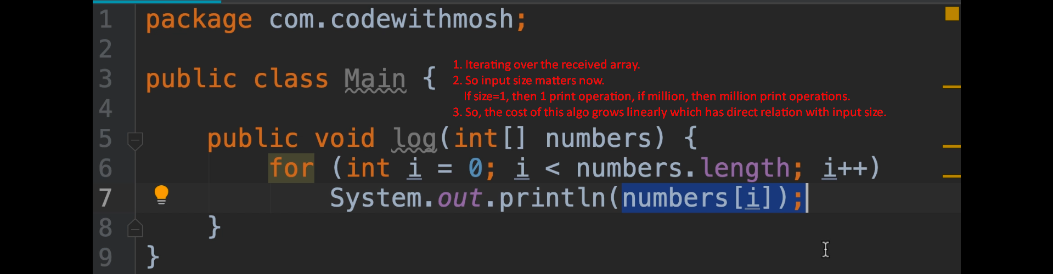
3. 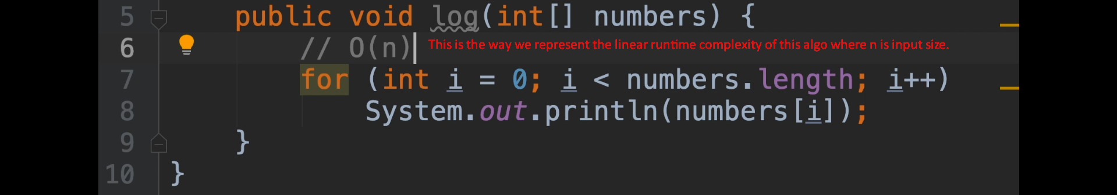
4. 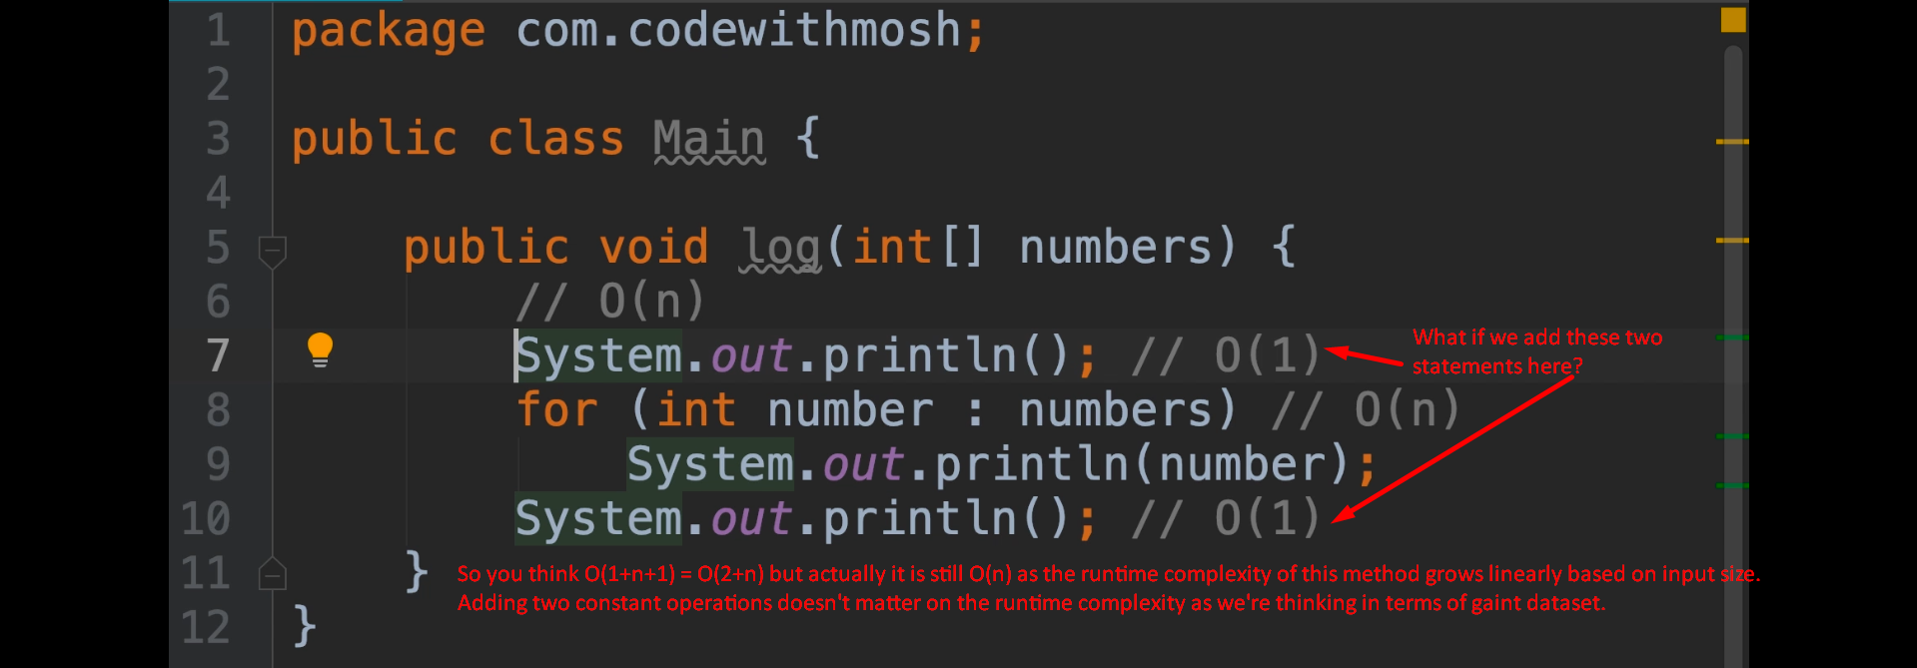
5. Linear Growth.
6. 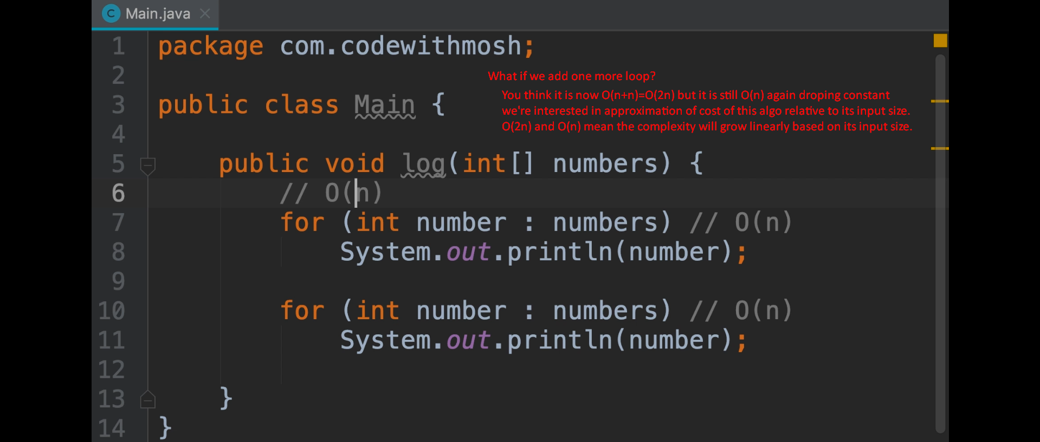
   1. What is runtime complexity of this method now?
   2. Both of these loops run in O(n).
7. 